EXERCISE 11
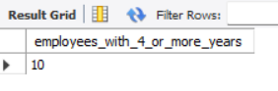
- Count the number of employees who have been with Bignet for four or more years.
SELECT COUNT(*) AS employees_with_4_or_more_years
FROM employee_data
WHERE yos >= 4;
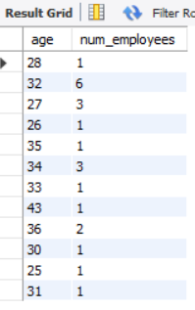
- Count employees based on their ages.
SELECT age, COUNT(*) AS num_employees
FROM employee_data
GROUP BY age;

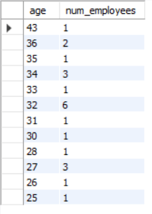
- Modify the above so that the ages are listed in a descending order.
SELECT age, COUNT(*) AS num_employees
FROM employee_data
GROUP BY age
ORDER BY age DESC;

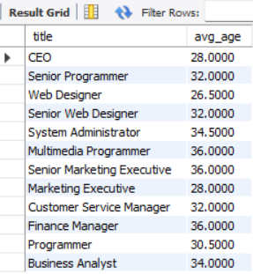
- Find the average age of employees in different departments (titles).
SELECT title, AVG(age) AS avg_age
FROM employee_data
GROUP BY title;

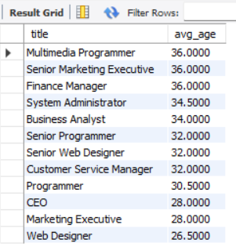
- Change the above statement so that the data is displayed in a descending order of average ages.
SELECT title, AVG(age) AS avg_age
FROM employee_data
GROUP BY title
ORDER BY avg_age DESC;

- Find and list the percentage perk (perk/salary X 100) for each employee with the % perks sorted in a descending order.
SELECT
f_name,
l_name,
salary,
perks,
(perks / salary * 100) AS "Perk Percentage"
FROM employee_data
ORDER BY `Perk Percentage` DESC; 